Clinical triggers and organ procurement care

Kylie Casey, APRN,^{1,2} Brianna L Doby, MPH,³ Katie Ross-Driscoll PhD, MPH,⁴ Raymond J. Lynch, MD, MS ^{4,5}

1. River City Pulmonology, Baptist Health System, San Antonio, Texas, USA
2. Johns Hopkins School of Nursing, Baltimore, Maryland, USA
3. Positive Rhetoric LLC, Bowling Green, Kentucky, USA
4. Division of Transplantation, Department of Surgery, Indiana University School of Medicine, Indianapolis, IN
5. Departments of Surgery and Public Health, Pennsylvania State University College of Medicine, Hershey, Pennsylvania, USA

ORCIDs:
Kylie Casey: 0000-0001-6318-9005
Brianna L. Doby: 0000-0001-9863-3276
Katie Ross-Driscoll: 0000-0002-8432-7419
Raymond J. Lynch: 0000-0001-8371-7514

WORD COUNT: X/3000
Corresponding author:
Raymond J Lynch, MD, MS, FACS
Professor of Surgery
Director of Transplantation Quality and Outcomes
Penn State Health Milton S. Hershey Medical Center
rlynch2@pennstatehealth.psu
(717) 531-6277 office

ABBREVIATIONS

CALC – Cause, Age, and Location Consistent deaths
CMS – Centers for Medicare and Medicaid Services
DSA – Donor Service Area
GCS – Glasgow Coma Scale
HRSA – Health Resources and Services Administration
JCAHO – Joint Commission on Accreditation of Healthcare Organizations
OPO – Organ Procurement Organization
OPTN – Organ Procurement and Transplantation Network

ABSTRACT

Despite the introduction of objective metrics for Organ Procurement Organization (OPO) productivity by the Centers for Medicare & Medicaid Services (CMS), there is still a paucity of publicly available data on OPO clinical processes. Characterizing OPO clinical practice patterns will inform quality improvement initiatives to improve not only the number of deceased donor organs recovered but also the quality and consistency of care provided to potential donor patients. We sought to describe the most upstream selection event in procurement care: the referral of a patient by a hospital to an OPO under what are known as “clinical triggers.” Clinical triggers refer to specific medical criteria or conditions that, when identified in a potential organ donor patient, prompt a hospital to initiate contact with an OPO. Data was gathered from 55/56 OPOs by direct contact with local nursing staff (39), Google search including academic presentations (9), OPOs (4), and hospital policies (3). Data were compared with SRTR-reported numbers of referrals to OPOs and OPTN and CMS data on potential and actual donors. Trigger cards were variable in both criteria for contacting OPOs and directions for patient care and family communication. Higher-performing OPOs had more donors per referral but not more referrals per cause, age, and location-consistent (CALC) death (Figure 1). Trigger complexity was not associated with greater rates of referral or of donors/referral, nor was a recent change to triggers. OPOs exhibit heterogeneous clinical practice and observed differences in performance appear after contact with OPOs rather than as a result of differences in referral rates. A detailed study of OPO processes is needed to standardize clinical care for OPO patients.

INTRODUCTION

The intricate process of organ transplantation is critically dependent on the timely and efficient recovery of organs. At the heart of this complex endeavor are OPOs. While they are indispensable in the transplantation chain, concerns have been raised about their role in the evident disparities in organ availability across regions.¹ These disparities significantly impact transplant centers' transplantation policies, behaviors, and, most importantly, patient outcomes.²

To address these concerns, the Centers for Medicare & Medicaid Services (CMS) implemented objective metrics to gauge OPO productivity. Concurrently, bodies like the Organ Procurement and Transplantation Network (OPTN) and the United Network for Organ Sharing (UNOS) have advocated for increased transparency within OPOs. The OPTN Modernization Initiative of 2023 formalized these entreaties while emphasizing its urgency.³ Yet, despite these concerted efforts a glaring void persists. The precise clinical practices, specifically the pivotal clinical triggers for organ referrals, have remained shrouded in mystery due to the scarcity of publicly accessible data.⁴ This lack of clarity has masked the potential inefficiencies and disparities of the organ donation process while most importantly, obscuring opportunities for refinement of the organ procurement process.

Previous efforts have taken aim at improving the national framework that governs OPOs without assessing or discussing the minutia of OPO operations such as their clinical triggers.⁵⁻⁷ The limited literature that does exist fails to provide a comprehensive comparison of OPO operations and protocols. This study shines light on the previously unreported topic by providing a complete and granular view of the current state of clinical practices by analyzing the clinical triggers employed across all OPOs. The primary objective of our study is to describe and analyze the variability in practices across OPOs, with the aim of informing evidence-based recommendations that can enhance organ procurement processes and patient care outcomes. We hypothesize that these variable practices contribute to the varying results observed, and as transplantation medicine continues to advance, demanding precision at every stage, it becomes increasingly essential to understand and refine these foundational processes.

METHODS
Data Collection:
We gathered data from various sources to analyze the clinical triggers used by OPOs. We reached out to hospital staff within OPO regions, reviewed information from OPO websites, and conducted thorough Google searches, which included academic presentations and hospital policies related to clinical triggers and organ donation. The data collection process is detailed in Figure 1.

We then recorded our interactions with each OPO, classifying the communications into positive data-sharing conversations, instances of no response, and refusals to communicate or share data. These interactions are categorized and displayed in Figure 2.

For each clinical trigger card obtained, we performed detailed coding to identify key features, such as references to the Glasgow Coma Scale (GCS), the threshold GCS score prompting OPO referral, and the number of absent brainstem reflexes required for referral. The coding and classification of these triggers are presented in Figure 3.

Refer My Patient Website:
After gathering the dataset as detailed above, our next step involved the coding of this data for analysis and visualization. To facilitate this process and provide a user-friendly platform for researchers and interested parties, we designed and developed an interactive web-based tool, which we named 'Refer My Patient.' Using JavaScript programming, we coded the dataset to ensure accurate representation and meaningful visualizations of clinical triggers collected. We hosted the interactive web-based tool, 'Refer My Patient,' on the GoDaddy.com platform.

Referrals and Donor Outcomes/ Statistical Analysis:
We collected data on organ procurement performance across 56 OPOs for the years 2020-2022. This included the number of donors per 100 cause, age, and location-consistent (CALC) deaths and the number of referrals from local hospitals. We also recorded the number of donors procured per referral to gauge the effectiveness of OPOs in managing potential donors.

To assess the correlation between referral rates and donor procurement, we stratified OPOs into quartiles based on their performance metrics. Quartile 1 represented the lowest performance, while the highest quartile represented the top performers. We analyzed two key relationships: (A) the correlation between the number of donors per 100 CALC deaths and referral rates, and (C) the correlation between the number of donors per 100 referrals and actual donor procurement.

We applied correlation analysis to evaluate the relationship between the referral rates from local hospitals and OPO procurement performance. A p-value of less than 0.001 was considered statistically significant. For panel C, we calculated donors per 100 referrals to determine the efficiency of OPOs in converting referrals to actual donors.

RESULTS
Clinical trigger data
Responses were received from nearly half (45.6%) of the OPOs contacted regarding their clinical trigger protocols. Of these, two-thirds (66.7%) mentioned the Glasgow Coma Scale (GCS) as part of their criteria. Guidance on managing family discussions about organ donation at the bedside was provided by an equivalent proportion (45.6%) of OPOs. The timeframe for initiating contact with an OPO varied up to 180 minutes between different organizations. Over half (52.6%) of the responding OPOs included brainstem reflex criteria, with variations in the number of absent reflexes required: 26.3% specified one, 19.3% required two, 5.3% needed three absent reflexes, and one response indicated a loss of 'some neurological reflexes' without further specification.

Communication with OPOs showed a range of concordance: some confirmed receipt and provided the requested information (Figure 2), while others did not respond or explicitly refused to share data. When analyzing the period of clinical triggers use, a range from as recent as the current year to over a decade ago was noted, reflecting a diversity in the update and revision practices among OPOs.

Visualization MAP

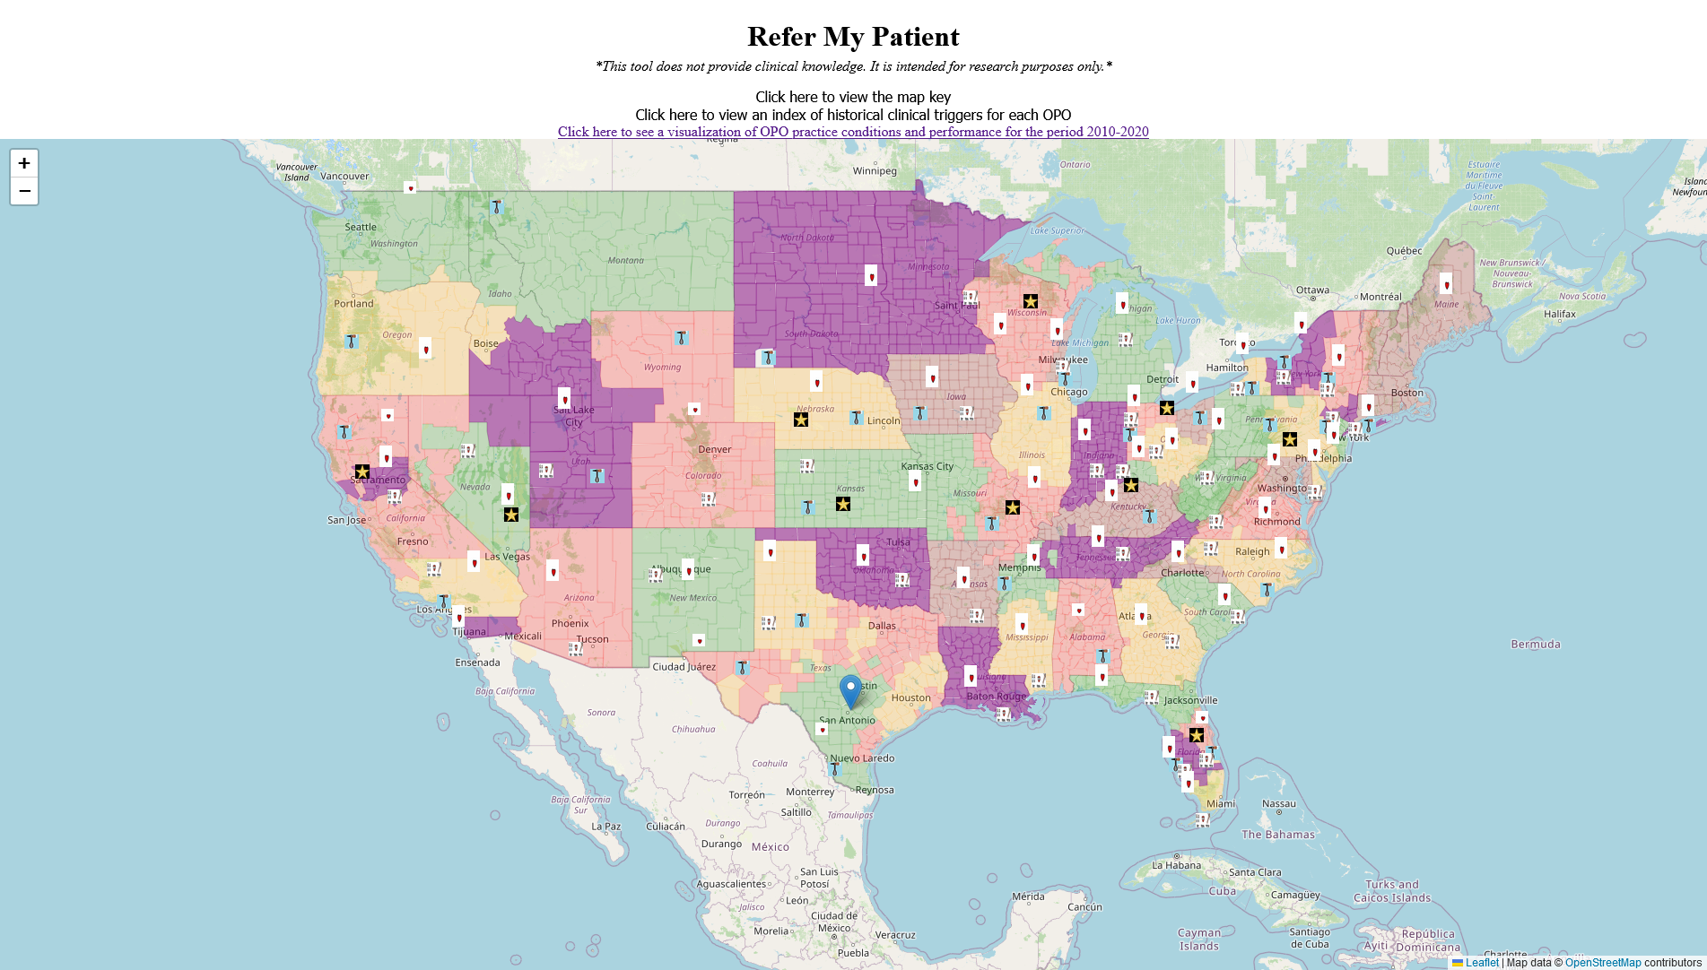
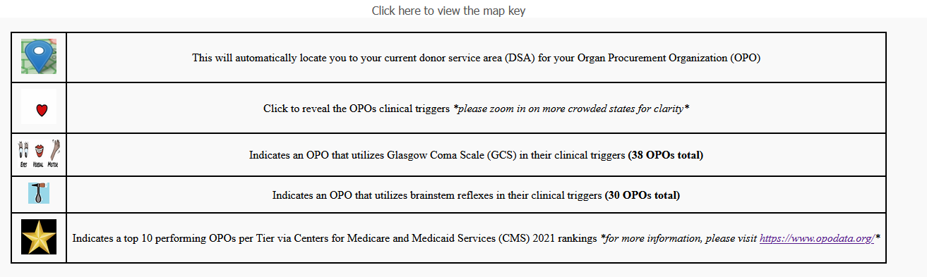

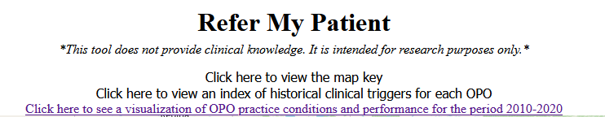
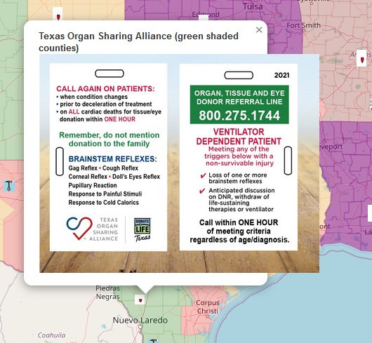
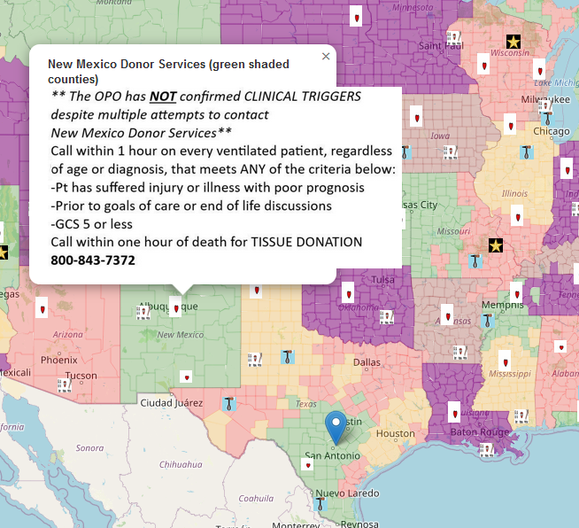

CALC Data
Analysis of the clinical trigger cards revealed variability in both the criteria for contacting OPOs and the directives for patient care and family communication. Notably, OPOs that performed better had a higher number of donors per referral, yet this did not correlate with an increase in referrals when adjusted for cause, age, and location-consistent (CALC) deaths, as shown in Figure 1. Moreover, the complexity of the trigger criteria did not align with higher referral rates or donor-to-referral ratios, and recent changes to these triggers were similarly not associated with performance improvements. This suggests that the observed differences in OPO performance are more likely to manifest after the initial contact with OPOs, rather than being influenced by variability in referral rates. Our data indicate a heterogeneity in clinical practices among OPOs.
DISCUSSION
Our study offers a pioneering insight into the clinical processes within OPOs and their consequential effect on the organ procurement landscape. Central to the organ procurement process is the concept of clinical triggers – specific criteria that, when met by a potential organ donor patient, prompt referral to an OPO. Our exploration into these triggers has unraveled a significant lack of standardization and transparency in OPO clinical practices. While OPOs serve as the nexus between potential donors and transplant recipients, a striking absence of nationally accepted standards for clinical triggers exists. This decentralization has created heterogeneity in how different OPOs approach the critical initial step of organ procurement. Interestingly, the disparities in organ procurement extend beyond mere differences in referral rates. Once contact has been established with OPOs, further discrepancies in performance and practices come to light.
Our study provides a thorough examination of the clinical processes within OPOs and their impact on the organ procurement system. We review the role of clinical triggers—the criteria used to determine when a potential organ donor patient should be referred to an OPO. Our analysis reveals significant variability and a lack of standardization in the application of these clinical triggers across different OPOs. Although OPOs are crucial in connecting donors with recipients, the absence of universal standards leads to varied practices at this initial, critical stage of organ procurement. Notably, our data suggest that after establishing initial contact with OPOs, there is considerable variability in performance and practices among these organizations, which points to the potential benefits of standardizing clinical triggers to achieve more consistent outcomes.

The lack of federal regulation by the Centers for Medicare & Medicaid Services (CMS) and the apparent non-enforcement of standards further complicates the landscape of organ procurement. Despite the CMS mandate for the bedside nurse to initiate contact upon a patient meeting a clinical trigger, the absence of penalties leaves this critical step susceptible to oversight. This situation is further exacerbated by inquiries from hospitals to the Joint Commission regarding the applicability of certain standards to OPOs, highlighting potential areas of ambiguity and confusion.⁸ In addressing these challenges, our study stands out by providing a detailed examination of OPO clinical triggers, an aspect significantly overlooked in previous research. Unlike prior efforts focused mainly on policy and framework improvements, our work delves deeply into the operational details of OPOs. This unique approach reveals a concerning reluctance among some OPOs to share information, which is perplexing and problematic given the life-saving nature of organ procurement. Our findings highlight a systemic issue within the organ procurement framework, calling for urgent attention and remediation through greater transparency and standardization to improve the efficacy and fairness of the system.

The lack of federal regulation by the Centers for Medicare & Medicaid Services (CMS) and the apparent non-enforcement of standards further complicates the landscape of organ procurement. Despite the CMS mandate for the bedside nurse to initiate contact upon a patient meeting a clinical trigger, the absence of penalties leaves this critical step susceptible to oversight. This situation is further exacerbated by inquiries from hospitals to the Joint Commission regarding the applicability of certain standards to OPOs, highlighting potential areas of ambiguity and confusion Our study, which provides a detailed examination of OPO clinical triggers—an aspect significantly overlooked in prior research—emphasizes the need for enhanced transparency throughout the organ procurement process. While previous efforts have mainly focused on policy and framework improvements, our exploration into the operational details of OPOs suggests that greater openness and information sharing at every phase could significantly improve the efficacy and fairness of the system. This approach is especially vital in the context of organ procurement, where transparency not only addresses systemic issues but is also critical for life-saving outcomes.

While our study provides comprehensive insights into OPO practices, it is important to acknowledge its limitations. One of the primary constraints is our limited ability to obtain data from all the operational OPOs. Despite our systematic approach, which utilized multiple data collection methods, we received responses from only a subset of OPOs, leaving a gap in understanding the complete landscape of OPO practices. Additionally, our study does not fully capture the level of compliance with OPOs regarding critical aspects such as the number of referrals, timeliness of responses, ventilation status, and pre-mention procedures. These are key elements that could significantly influence the effectiveness of OPO operations but remain unexplored due to data constraints. Despite these limitations, the development of the 'Refer My Patient' web-based tool stands as a significant achievement of our study. This innovative and interactive platform, which visualizes clinical trigger data, not only underlines the rigor of our research approach but also serves as a valuable resource for the broader organ transplantation community, enhancing the landscape of current research.

In analyzing the reasons behind our study's results, it becomes evident that clinical care practices play a crucial role in the organ procurement process. Our findings indicate that OPOs with better performance metrics, as per CMS standards, demonstrate higher donor-to-referral ratios, suggesting the significant impact of actions taken post-referral. This observation is consistent with our previous research, which demonstrated that enhanced OPO practices led to a significant increase in referrals. In this study, we documented a 44% rise in donor yield and a 29% increase in organs transplanted, results that were directly attributable to data-informed improvements in OPO operations.⁹ These results underscore the potential of OPOs to amplify organ donation rates by refining their practices after the referral point. Such insights are crucial for understanding the diverse outcomes observed across various OPOs. They point to the need for a holistic focus on OPO operations, encompassing not just the initiation of the referral process but also the quality and efficiency of the actions that follow, highlighting how effective management and clinical practices can lead to improved outcomes in organ procurement.

Our study offers pioneering insights into the clinical processes within OPOs, highlighting significant heterogeneity and a lack of transparency in their practices, especially regarding 'clinical triggers.' The absence of nationally accepted standards for these triggers creates disparities in how OPOs approach organ procurement, a concern compounded by the lack of federal regulation and non-enforcement of standards by the CMS. This situation is exacerbated by the incomplete response from OPOs and the difficulty in assessing their compliance with critical aspects like referral numbers and timeliness. Despite these challenges, our findings show that OPOs with better performance metrics have higher donor-to-referral ratios, emphasizing the impact of post-referral actions, as also seen in our previous research which documented a significant rise in donor yield and organs transplanted due to improved OPO operations. These insights underline the necessity of process data for a comprehensive understanding of OPO functions and suggest the potential of tools like 'Refer My Patient' for enhancing research and practices in organ transplantation. Our study underscores the urgent need for standardized processes and clearer data reporting within OPOs, pointing towards a future direction of research focused on operational nuances and compliance levels, which could ultimately pave the way for a more effective organ procurement system.

FUNDING SOURCES

Ms. Doby and Dr. Lynch are funded in part by the National Institute on Minority Health and Health Disparities (NIH R01 MD017046).

DISCLOSURES

Ms. Doby and Dr. Lynch have previously received research funding from Mid-America Transplant Foundation. Ms. Doby reports consulting fees from Arkansas Regional Organ Recovery Agency, Mid-America Transplant, Justice Catalyst Law, and Organ Alliance, Inc. outside the submitted work.

DATA AVAILABILITY STATEMENT

Data included in this manuscript was gathered under data use agreements with the National Center for Health Statistics and the Scientific Registry of Transplant Recipients, and are available as such to interested parties. Additional publicly-available data was gathered from online resources without necessity of payment or data use agreements from the Organ Procurement and Transplantation Network contractor and the Department of Homeland Security’s Homeland Infrastructure Foundation-Level Data websites.

FIGURE LEGENDS

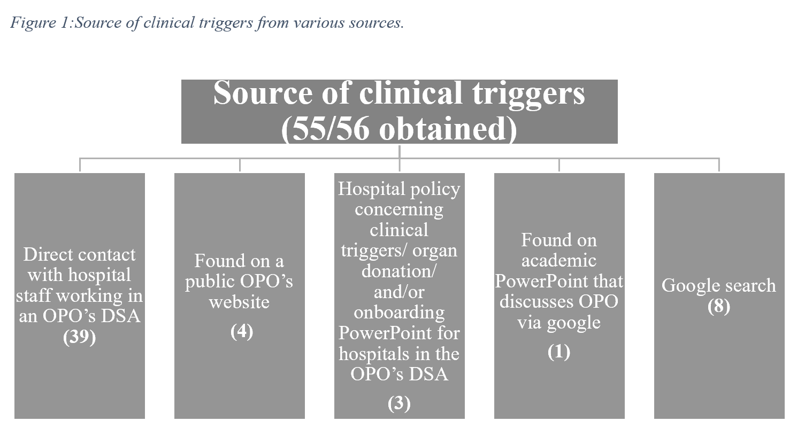

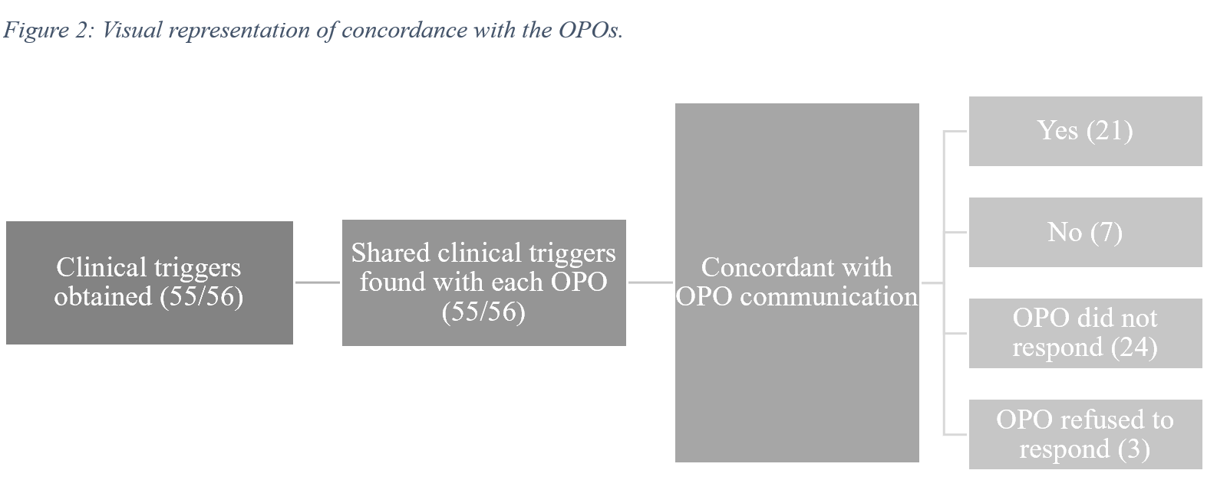

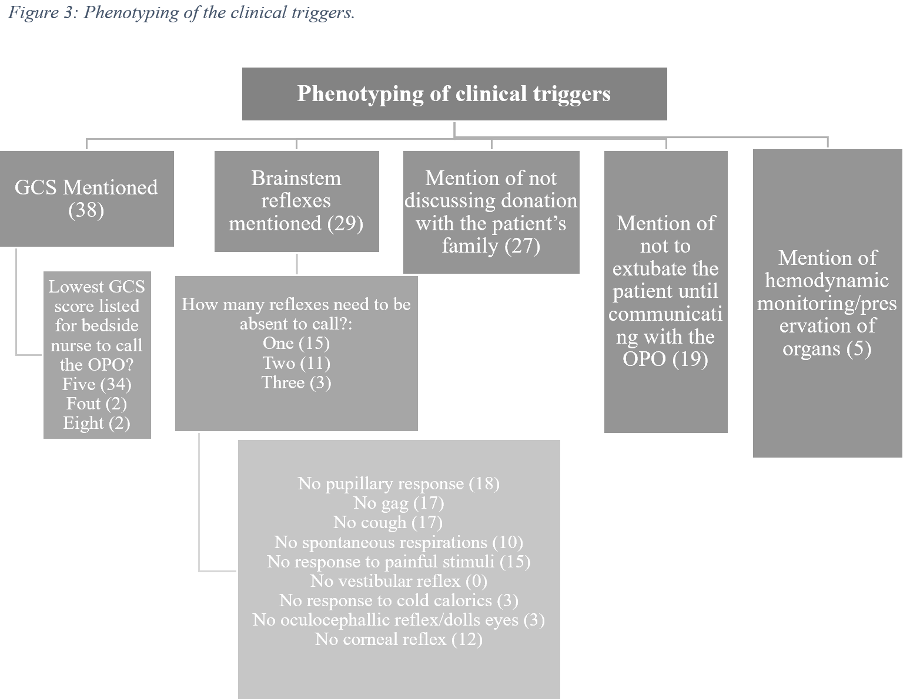

References

1. Doby BL, Casey K, Ross-Driscoll K, et al. What is visible is fixable: Visual dashboards for multi-domain assessment of organ procurement organization performance. American Journal of Transplantation. 2023/08/30/ 2023;doi:https://doi.org/10.1016/j.ajt.2023.08.020
2. Weimer DL. Public and private regulation of organ transplantation: liver allocation and the final rule. J Health Polit Policy Law. Feb 2007;32(1):9-49. doi:10.1215/03616878-2006-027
3. HRSA Announces Organ Procurement and Transplantation Network Modernization Initiative 3/22/2023, 2023.
4. Kasiske BL, Salkowski N, Wey A, Israni AK, Snyder JJ. Potential Implications of Recent and Proposed Changes in the Regulatory Oversight of Solid Organ Transplantation in the United States. Am J Transplant. Dec 2016;16(12):3371-3377. doi:10.1111/ajt.13955
5. Wicclair MR, DeVita M. Oversight of research involving the dead. Kennedy Inst Ethics J. Jun 2004;14(2):143-64. doi:10.1353/ken.2004.0025
6. Howard RJ, Cornell DL, Schold JD. CMS oversight, OPOs and transplant centers and the law of unintended consequences. Clinical Transplantation. 2009;23(6):778-783. doi:https://doi.org/10.1111/j.1399-0012.2009.01157.x
7. Hall MD S, Alam MD A, Levine MD D, Barac MD, Yaron. Transplant Organizations, Oversight, Structure, and Allocation Process: Worldwide Perspective. Textbook of Transplantation and Mechanical Support for End‐Stage Heart and Lung Disease. 2023:30-52.
8. 34 Clarifying Standards Applicability to Organ Procurement Organizations (Joint Commission Perspective) (2014).
9. Doby BL, Hanner K, Johnson S, Purnell TS, Shah MB, Lynch RJ. Results of a data-driven performance improvement initiative in organ donation. Am J Transplant. Jul 2021;21(7):2555-2562. doi:10.1111/ajt.16442

